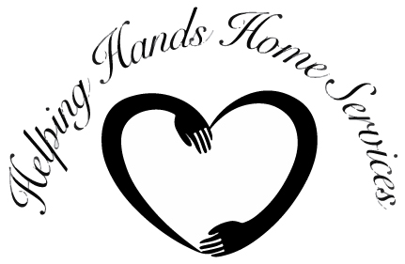

Web Style Guide

*Last Updated: November 2013*

**Web Style Guide Index**

1. Introduction
2. Required Elements
3. Color Values
4. Typography
5. Cascading Style Sheets
6. Page Guidelines and Templates
7. Logo Identity and Branding Standards
8. Accessibility
9. Best Practices on the Web
10. Content Guidelines
11. Contact Us
12. **Introduction**

This style guide applies only to official Organization pages. Official Organization pages are defined as web pages on an Organization web server that have been created by authorized employees of the Organization. It does not apply to web pages created by non-authorized individuals.

When a user visits the Helping Hands Home Services web site, they take away with them an impression of the Organization and its employees. To ensure a unified web presence, official pages of the Organization’s web site should appear to be visually related in order to help promote usability and to reinforce the Organization’s identity.

Although consistency is important, this style guide takes into consideration the fact that design standards may vary for individual applications. There are several versions of branded templates to assist in the creation of your web site. While the variety of templates offered may reflect elements of the Organization’s homepage, there are no templates that duplicate the organization’s homepage. If you choose not to utilize the templates, elements of the style guide, such as color and font standards, may be adopted for use in your design.

However, if you wish to make creative modifications to the templates, please contact the organization’s web designer in the early stages of redesigning your page. While there is the option of choosing between several templates, there are certain required elements, which are outlined in the Required Elements section of the style guide.

1. **Required Elements**

All official (see Section I.) Helping Hands Home Services web pages must contain the following elements:

1. Helping Hands Home Services logo

*<INSERT FINAL WEB LOGO HERE>*

**Do not alter or manipulate the organization logo in any way. Inappropriate use of the logo will dilute its effectiveness. Therefore, the organization logo may not be redrawn, reconstructed, or modified in any way.**

1. All official organization web pages are required to include a link back to the Helping Hands Home Services homepage. The link should be easy for users to find and in a font size that is clearly visible.

**Recommended versions:**

1. Header logo and link

When the link to the Helping Hands Home Services homepage is in the header, the required version is the organization logo as a link back to the homepage.

For example:

*<INSERT FINAL WEB LOGO HERE>*

The required width and height for the organization logo in the header is x pixels by y pixels.

1. Toolbar link

A link to the organization homepage must be incorporated in the toolbar of the template as provided in this style guide.

For example:

*<INSERT NAVBAR HERE>*

1. **Color Values**

**Colors Used on the Helping Hands Home Services Web Site**

The colors below represent the hexadecimal and RGB values of the colors that appear on the central Helping Hands Home Services web site.

**Color R G B HEX Value**

Deep Koamaru 18 48 110 12306E

Denim 24 106 180 186AB4

Seashell 241 241 241 F1F1F1

Blue Haze 194 205 220 C2CDDC

Bamboo 218 95 11 DA5F0B

1. **Typography**
2. **Cascading Style Sheet**
3. **Page Guidelines and Templates**
4. **Logo Identity and Branding Standards**
5. **Accessibility**
6. **Best Practices on the Web**
7. **Content Guidelines**
8. **Contact Us**